Walking in the Air
Voice wanted for performance of
The Snowman with Hitchin Band
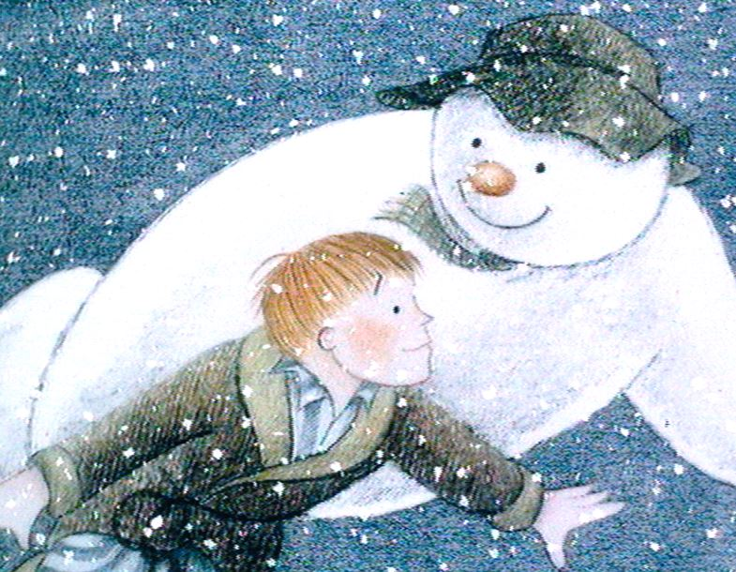
Back by popular demand following three sell out years!
Do you have the voice to sing “Walking in the Air” from The Snowman?
Applications are invited to audition for the solo vocal part in Hitchin Band's performances of The Snowman at St Mary’s Church, Hitchin and The Broadway Theatre, Letchworth.
Our star singers will have the opportunity to perform alongside a 25-piece Championship Section Brass Band to provide the musical accompaniment to the animated film The Snowman.
- St Mary's Church Hitchin: Saturday 4th December 2021 - 3:30 pm, 4:45 pm & 6:00 pm
- The Broadway Theatre, Letchworth Sunday 5th December 2021 - 10:00 & 11.30am
A total of five performances are planned and so more than one soloist will be required. Auditions are open to boys and girls aged 8-16 years old (boys require an ‘unbroken’ treble voice) Parents/Guardians please register children for auditions by 6pm, Sunday 10th October. Application forms can be found on our website. Audition material and further details will be sent out by email once registration is closed. An audio recording will need to be submitted by 6pm on Sunday 24th October. Shortlisted singers will be invited to a live audition. Successful applicants will need to be available for daytime rehearsal on Saturday 6th and 20th November plus additional rehearsals if required.
Please send applications to Dinah Birch dinahb64@googlemail.com
Chairperson, Hitchin Band
www.hitchinband.co.uk

“The Snowman” by Raymond Briggs is published by Puffin
Image © Snowman Enterprises Ltd
www.thesnowman.com

The Snowman with Hitchin Band - Vocal Audition Application

Performance dates:

St Mary's Church Hitchin: Saturday 4th December 2021

The Broadway, Letchworth: Sunday 5th December 2021
- Parent/Guardian Name, Address and Contact Details
Parent / Guardian Name
Address
Address 2
Town
Post Code
Email Address
Phone Number
- Child's Full Name
- Child's Age: (Must be between 8 and 16, boys with 'unbroken' treble voice)
- Please confirm the performance dates and venues that you are applying for: (tick either or both)

☐ My child would be available between 12pm and 6:30pm in Hitchin, Saturday 4th December
☐ My child would be available between 9am and 12pm in Letchworth, Sunday 5th December
- Please confirm your child's availability for rehearsals in November.
☐ My child would be available for daytime rehearsals on Saturday 6th and Saturday 20th November.
☐ My child would be available for additional rehearsals on Thursday evenings in November
Please state any Thursday evenings that your child is not available in November:
- Parent/Guardian: Do you give permission for the press or media to contact you?
☐ YES ☐ NO
- Parent/Guardian: Do you give permission for your child's name and photo to be used for promotional purposes?
☐ YES ☐ NO
- Parent/Guardian: Chaperoning
☐ YES: I confirm that my child will be accompanied during auditions, rehearsals and performances by myself or another responsible adult on my behalf.
- Parent/Guardian: General Data Protection Regulations
☐ YES: I accept that by making this application I agree to the information I provide being used for the purposes of processing audition applications, managing auditions, rehearsals, performances and reviews, and that it will be used only by official members of Hitchin Band involved in managing these activities. I accept that the information will be retained until the completion of these activities.
Parent / Guardian Name
Date
Completed forms to be sent to dinahb64@googlemail.com by 6pm, Sunday 10th October 2021

